**Exercise 1: Implementing the Singleton Pattern**

**Scenario:**

You need to ensure that a logging utility class in your application has only one instance throughout the application lifecycle to ensure consistent logging.

**Steps:**

1. **Create a New Java Project:**
   * Create a new Java project named **SingletonPatternExample**.
2. **Define a Singleton Class:**
   * Create a class named Logger that has a private static instance of itself.
   * Ensure the constructor of Logger is private.
   * Provide a public static method to get the instance of the Logger class.
3. **Implement the Singleton Pattern:**
   * Write code to ensure that the Logger class follows the Singleton design pattern.
4. **Test the Singleton Implementation:**
   * Create a test class to verify that only one instance of Logger is created and used across the application.

**SOLUTION:**using System;

namespace SingletonApp

{

public class Logger

{

private static Logger? _instance;

private Logger()

{

Console.WriteLine("Logger instance created.");

}

public static Logger GetInstance()

{

_instance ??= new Logger();

return _instance;

}

public void Log(string message)

{

Console.WriteLine($"[LOG]: {message}");

}

}

class Program

{

static void Main(string[] args)

{

Logger logger1 = Logger.GetInstance();

logger1.Log("First log message");

Logger logger2 = Logger.GetInstance();

logger2.Log("Second log message");

Console.WriteLine($"Are both instances the same? {ReferenceEquals(logger1, logger2)}");

}

**}**

**}  
  
OUTPUT: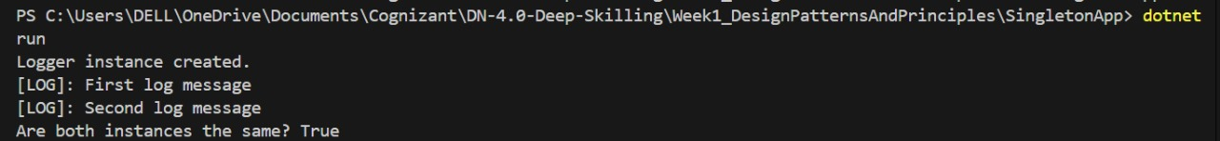 Exercise 2: Implementing the Factory Method Pattern**

**Scenario:**

You are developing a document management system that needs to create different types of documents (e.g., Word, PDF, Excel). Use the Factory Method Pattern to achieve this.

**Steps:**

1. **Create a New Java Project:**
   * Create a new Java project named FactoryMethodPatternExample.
2. **Define Document Classes:**
   * Create interfaces or abstract classes for different document types such as WordDocument, PdfDocument, and ExcelDocument**.**
3. **Create Concrete Document Classes:**
   * Implement concrete classes for each document type that implements or extends the above interfaces or abstract classes.
4. **Implement the Factory Method:**
   * Create an abstract class DocumentFactory with a method createDocument().
   * Create concrete factory classes for each document type that extends DocumentFactory and implements the createDocument() method.
5. **Test the Factory Method Implementation:**
   * Create a test class to demonstrate the creation of different document types using the factory method.

**SOLUTION:**

using System;

interface IDocument

{

void Open();

}

class WordDocument : IDocument

{

public void Open()

{

Console.WriteLine("Opening Word Document.");

}

}

class PdfDocument : IDocument

{

public void Open()

{

Console.WriteLine("Opening PDF Document.");

}

}

class ExcelDocument : IDocument

{

public void Open()

{

Console.WriteLine("Opening Excel Document.");

}

}

class Program

{

static void Main()

{

Console.WriteLine("Enter the type of document to open (word/pdf/excel):");

string input = Console.ReadLine()?.ToLower();

IDocument document = input switch

{

"word" => new WordDocument(),

"pdf" => new PdfDocument(),

"excel" => new ExcelDocument(),

_ => null

};

if (document != null)

{

document.Open();

}

else

{

Console.WriteLine("Invalid input. Please enter 'word', 'pdf', or 'excel'.");

}

}

}  
  
**OUTPUT:**  
  
